**Web based Fitness Management System**

**Software Requirements Specification**

Version 1.0



**Group Id: S25PROJECTAAFAD**

**Supervisor Name : Qaiser Shabbir**

**Revision History**

|  |  |  |  |
| --- | --- | --- | --- |
| Date (dd/mm/yyyy) | Version | Description | Author |
| 9/5/2025 | 1.0 | This SRS outlines the functional and non-functional requirements for a Fitness Management System designed to streamline the operations of a modern gym. The system involves three core entities: Admin, Member, and Trainer, all interconnected to ensure smooth functionality. It offers a user-friendly interface, secure access, and automation features that significantly reduce manual work and staff requirements, while improving communication between trainers and members.The system ensures secure online payments, appointment booking, automated email and SMS alerts for upcoming sessions, and real-time updates about fitness progress. Developed using the VU Process Model with a blend of Waterfall and Spiral methodologies, this system provides a complete solution for digital gym management with improved communication, transparency, and performance tracking. | BC200415696 |
|  |  |  |  |
|  |  |  |  |
|  |  |  |  |

**Table of Contents**

1. Scope (of the project) Page No**: 04**
2. Functional Requirements Non Functional requirements Page No: **05**
3. Use Case Diagram Page No: **06**
4. Usage Scenarios  Page No: **07**
5. Adopted Methodology  Page No: **25**
6. Work Plan (Use MS Project to create Schedule/Work Plan)__________Page No: **29**

SRS Document

# *1. Scope Of Project:-*

# The scope of the Fitness Management System is to build a comprehensive, web-based platform that streamlines gym operations and fosters seamless interaction among three primary users: Admin, Trainer, and Member. This system addresses the increasing demand for digital fitness solutions by automating key processes such as membership handling, workout scheduling, trainer allocation, payment processing, and progress tracking. The objective is to minimize manual intervention while enhancing operational efficiency and accuracy throughout the fitness center.Admins will operate through a secure dashboard that allows full control over gym activities. They can register new members, update or remove member profiles, assign trainers to appropriate shifts, and oversee daily operations. Admins are also empowered to create and manage trainer profiles, monitor their schedules, and maintain oversight of the entire system. By digitizing these functions, the platform reduces reliance on a large administrative workforce and lowers the risk of errors or scheduling issues.The Member module is designed to enhance convenience and autonomy by offering tools to manage memberships, book classes, track fitness progress, and make payments online via secure channels. Members will receive automated alerts about class timings, payment due dates, and trainer feedback, improving engagement and user experience. Additionally, the system allows members to rate sessions and trainers, fostering transparency and continuous improvement in service quality.Trainers are provided with efficient tools to manage their clients effectively. They can develop customized workout and nutrition plans, adjust them according to member progress, and record attendance. Trainers can also receive feedback ratings, contributing to their ongoing professional development.

# In summary, the Fitness Management System aims to offer a secure, scalable, and user-friendly solution that unifies all aspects of gym management. It automates administrative workflows, promotes effective communication, and builds a transparent, professional relationship between members and trainers. By enabling real-time data access and automating routine tasks, the system becomes a vital asset for modern fitness centers striving for improved performance, member satisfaction, and business growth.

# *2.1 Functional Requirements:-*

In this system, there are three entities which are namely Admin, Member and Trainer. Each entity is interconnected to each other. This system should be user-friendly, and secure and reduce the staff requirements. This system should also be best for communicating with the members

1. Admin can log in using credentials.
2. Admin can add new members.
3. Admin can delete the members who left the gym.
4. Admin can add new trainer can be added.
5. Admin will manage trainer profiles and availability.
6. Admin can unwanted trainers can be deleted.
7. Admin will modify the data of members.
8. Admin will modify trainers shift.
9. Members can purchase, renew, and track their membership plans.
10. Members can log and track their fitness progress over time.
11. Members can review trainers and rate sessions.
12. Member can log in using credentials.
13. Members can pay money by using electronic transfer.
14. Trainer can log in using credentials.
15. Trainers can create, modify, and assign workout plans to clients.
16. Trainers can provide and update dietary recommendations.
17. Members can book appointments with trainers and fitness classes.
18. Trainer can mark the attendance of the members.
19. Secure online payment options for membership fees and trainer bookings.
20. Automated email and SMS notifications for schedules, payments, and progress updates.

# *2.2 Non-Functional Requirements:-*

1. Security – Secure authentication, data encryption, and compliance with industry security standards.
2. Performance – The system should handle multiple concurrent users without performance degradation.
3. Scalability – Ability to scale up to accommodate more users and fitness centres.
4. Usability – Intuitive and user-friendly interface for all users.
5. Availability – The system should have high uptime and reliability.
6. Compatibility – The platform should be accessible across different web browsers and devices. Maintainability – Easy to update and modify features without major downtime.
7. Backup & Recovery – Regular data backups and recovery mechanisms to prevent data loss.

# *3. Use Case Diagram:-*

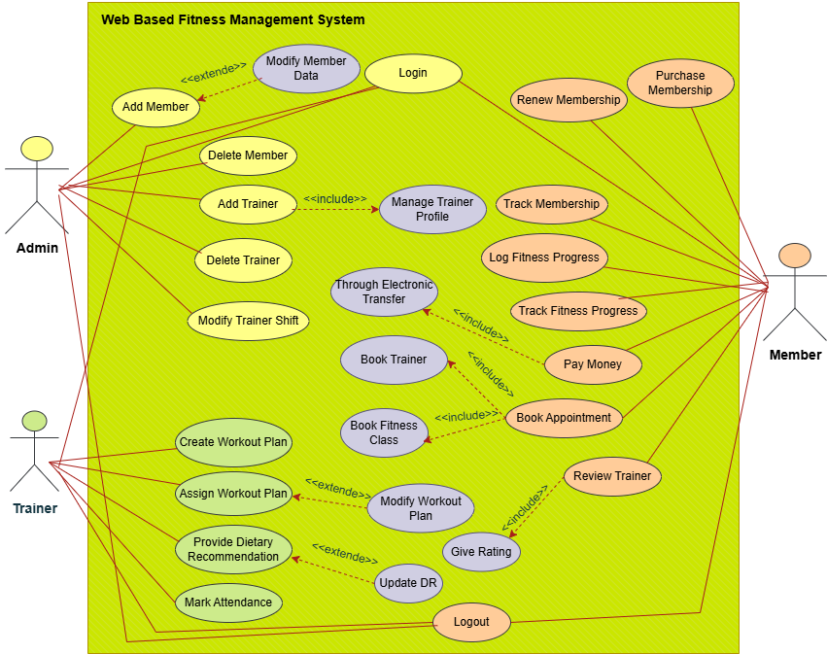

# 4. Usage Scenario Tables:-

## 1: Use Case-Admin Login

|  |  |
| --- | --- |
| Use Case Title | Admin Login |
| Use Case ID | WFMS-Admin-Login-01 |
| FR-ID | FR-001 |
| Actors | Admin |
| Description | This use case allows the admin to securely log in to the Gym Management System. |
| Alternative Path | 1. Forgot password flow 2. Two-factor authentication (if enabled) |
| Pre Conditions | Admin has a valid registered account |
| Action | 1. Open login page 2. Enter credentials 3. Click Login button |
| Post Conditions | Admin is redirected to the admin dashboard upon successful login |
| Author | BC200415696 |
| Exception | 1. Invalid credentials 2. Account locked 3. Server timeout |

## 2: Use Case-Add Member

|  |  |
| --- | --- |
| Use Case Title | Add Member |
| Use Case ID | WFMS-Admin-AddMember-02 |
| FR-ID | FR-002 |
| Actors | Admin |
| Description | Admin can add new gym members to the system |
| Alternative Path | 1. Import members via CSV 2. Auto-generate member ID |
| Pre Conditions | Admin is logged into the system |
| Action | 1. Navigate to Add Member 2. Fill member info 3. Click Submit |
| Post Conditions | New member is saved in the database and visible in member list |
| Author | BC200415696 |
| Exception | 1. Duplicate CNIC/ID 2. Missing required fields 3. Database error |

## 3: Use Case-Delete Member

|  |  |
| --- | --- |
| Use Case Title | Delete Member |
| Use Case ID | WFMS-Admin-DeleteMember-03 |
| FR-ID | FR-003 |
| Actors | Admin |
| Description | Admin can delete members who left the gym |
| Alternative Path | 1. Archive member instead of delete 2. Soft delete |
| Pre Conditions | Member exists in the system |
| Action | 1. Select member from list 2. Click Delete 3. Confirm deletion |
| Post Conditions | Member is removed or marked inactive in the system |
| Author | BC200415696 |
| Exception | 1. Member not found 2. Unauthorized access 3. Database connection lost |

## 4: Use Case-Modify Member Data

|  |  |
| --- | --- |
| Use Case Title | Modify Member Data |
| Use Case ID | WFMS-Admin-ModifyMember-04 |
| FR-ID | FR-004 |
| Actors | Admin |
| Description | Admin updates information of existing members |
| Alternative Path | 1. Edit limited fields 2. View-only mode for restricted admins |
| Pre Conditions | Admin is logged in; member exists |
| Action | 1. Search member 2. Click Edit 3. Update fields 4. Save |
| Post Conditions | Updated data is reflected in member profile |
| Author | BC200415696 |
| Exception | 1. Invalid input 2. System validation errors 3. Update conflict |

## 5: Use Case-Add Trainer

|  |  |
| --- | --- |
| Use Case Title | Add Trainer |
| Use Case ID | WFMS-Admin-AddTrainer-05 |
| FR-ID | FR-005 |
| Actors | Admin |
| Description | Admin can add new trainers to the system. |
| Alternative Path | 1. Import trainers via CSV 2. Auto-generate trainer ID |
| Pre Conditions | Admin is logged into the system |
| Action | 1. Navigate to Add Trainer 2. Fill trainer info 3. Click Submit |
| Post Conditions | New trainer is saved in the database and visible in trainer list |
| Author | BC200415696 |
| Exception | 1. Duplicate Email/ID 2. Missing required fields 3. Database error |
| Modification History | v1.1 |

## 6: Use Case-Modify Trainer Shift

|  |  |
| --- | --- |
| Use Case Title | Modify Trainer Shift |
| Use Case ID | WFMS-Admin-ModifyShift-06 |
| FR-ID | FR-006 |
| Actors | Admin |
| Description | Admin can modify the shift timings of trainers. |
| Alternative Path | 1. Bulk update shifts 2. Revert changes |
| Pre Conditions | Trainer exists in system and admin is logged in |
| Action | 1. Locate trainer profile 2. Edit shift info 3. Save changes |
| Post Conditions | Shift is updated in the system |
| Author | BC200415696 |
| Exception | 1. Invalid time entry 2. Conflict with another shift 3. Network error |
| Modification History | v1.1 |

## 7: Use Case-Manage Trainer Profile

|  |  |
| --- | --- |
| Use Case Title | Manage Trainer Profile |
| Use Case ID | WFMS-Admin-ManageTrainer-07 |
| FR-ID | FR-007 |
| Actors | Admin |
| Description | Admin manages trainer's profile including name, contact, and expertise. |
| Alternative Path | 1. Partial update 2. Assign specialization |
| Pre Conditions | Trainer is registered in system |
| Action | 1. Search trainer 2. Edit profile details 3. Click Save |
| Post Conditions | Trainer's profile information is updated |
| Author | BC200415696 |
| Exception | 1. Field validation error 2. Missing data 3. Concurrent modification |
| Modification History | v1.1 |

## 8: Use Case-Purchase Membership

|  |  |
| --- | --- |
| Use Case Title | Purchase Membership |
| Use Case ID | WFMS-Member-PurchaseMembership-08 |
| FR-ID | FR-008 |
| Actors | Member |
| Description | Members can purchase new gym membership plans. |
| Alternative Path | 1. Choose different plan 2. Use discount code |
| Pre Conditions | Member is registered and logged in |
| Action | 1. Choose plan 2. Make payment 3. Confirm purchase |
| Post Conditions | Membership is activated |
| Author | BC200415696 |
| Exception | 1. Payment failure 2. Plan unavailable 3. Invalid promo code |
| Modification History | v1.1 |

## 9: Use Case-Renew Membership

|  |  |
| --- | --- |
| Use Case Title | Renew Membership |
| Use Case ID | WFMS-Member-RenewMembership-09 |
| FR-ID | FR-009 |
| Actors | Member |
| Description | Members can renew their existing gym memberships. |
| Alternative Path | 1. Select different duration 2. Extend before expiry |
| Pre Conditions | Membership nearing expiry |
| Action | 1. Navigate to membership section 2. Choose renew 3. Complete payment |
| Post Conditions | Membership renewed successfully |
| Author | BC200415696 |
| Exception | 1. Payment declined 2. System error 3. Expired membership not found |
| Modification History | v1.1 |

## 10: Use Case-Track Membership

|  |  |
| --- | --- |
| Use Case Title | Track Membership |
| Use Case ID | WFMS-Member-TrackMembership-10 |
| FR-ID | FR-010 |
| Actors | Member |
| Description | Members can view status and expiry of their current memberships. |
| Alternative Path | 1. View renewal history 2. Filter by date |
| Pre Conditions | Membership must be active |
| Action | 1. Go to dashboard 2. Click Membership Info |
| Post Conditions | Membership info displayed |
| Author | BC200415696 |
| Exception | 1. No active membership 2. Data retrieval error 3. Dashboard loading issue |
| Modification History | v1.1 |

## 11: Use Case: Log Fitness Progress

|  |  |
| --- | --- |
| Use Case Title | Log Fitness Progress |
| Use Case ID | WFMS-Member-LogProgress-11 |
| FR-ID | FR-011 |
| Actors | Member |
| Description | Members can log daily fitness activities like workouts and calories. |
| Alternative Path | 1. Upload via fitness tracker 2. Bulk upload for week |
| Pre Conditions | Member is logged in |
| Action | 1. Open progress section 2. Input data 3. Submit |
| Post Conditions | Progress is saved to the database |
| Author | BC200415696 |
| Exception | 1. Missing required data 2. Format mismatch 3. Submission error |
| Modification History | v1.1 |

## 12: Use Case-Track Fitness Progress

|  |  |
| --- | --- |
| Use Case Title | Track Fitness Progress |
| Use Case ID | WFMS-Member-TrackProgress-12 |
| FR-ID | FR-012 |
| Actors | Member |
| Description | Members can view their logged fitness progress over time. |
| Alternative Path | 1. Graph view 2. Weekly/monthly filter |
| Pre Conditions | Progress data must exist |
| Action | 1. Open progress section 2. Choose timeframe |
| Post Conditions | Progress data is displayed |
| Author | BC200415696 |
| Exception | 1. Data not found 2. Display error |
| Modification History | v1.1 |

## 13: Use Case-Make Payment

|  |  |
| --- | --- |
| Use Case Title | Pay Money |
| Use Case ID | WFMS-Member-MakePayment-13 |
| FR-ID | FR-013 |
| Actors | Member, Payment System |
| Description | Members can make membership or appointment payments online. |
| Alternative Path | 1. Choose different payment method 2. Use promo code |
| Pre Conditions | Payment system is online |
| Action | 1. Choose service 2. Initiate payment 3. Confirm transaction |
| Post Conditions | Payment confirmed and recorded |
| Author | BC200415696 |
| Exception | 1. Transaction declined 2. Network issue 3. Gateway timeout |
| Modification History | v1.1 |

## 14: Use Case-Give Rating

|  |  |
| --- | --- |
| Use Case Title | Give Rating |
| Use Case ID | WFMS-Member-GiveRating-14 |
| FR-ID | FR-014 |
| Actors | Member |
| Description | Members can give a rating after completing a session with a trainer. |
| Alternative Path | 1. Skip rating 2. Rate anonymously |
| Pre Conditions | Member attended session |
| Action | 1. Navigate to session history 2. Submit rating |
| Post Conditions | Rating is stored |
| Author | BC200415696 |
| Exception | 1. Rating not accepted 2. Already rated |
| Modification History | v1.1 |

## 15: Use Case-Book Appointment

|  |  |
| --- | --- |
| Use Case Title | Book Appointment |
| Use Case ID | WFMS-Member-BookAppointment-15 |
| FR-ID | FR-015 |
| Actors | Member, Trainer |
| Description | Members can book one-on-one appointments with available trainers. |
| Alternative Path | 1. Book group class 2. Set recurring appointment |
| Pre Conditions | Trainer is available |
| Action | 1. Select trainer 2. Choose date/time 3. Confirm booking |
| Post Conditions | Appointment is booked |
| Author | BC200415696 |
| Exception | 1. Slot not available 2. Booking failed |
| Modification History | v1.1 |

## 16: Use Case-Review Trainer

|  |  |
| --- | --- |
| Use Case Title | Review Trainer |
| Use Case ID | WFMS-Member-ReviewTrainer-16 |
| FR-ID | FR-016 |
| Actors | Member |
| Description | Members can write reviews for trainers based on their experience. |
| Alternative Path | 1. Edit review later 2. View all previous reviews |
| Pre Conditions | Trainer session completed |
| Action | 1. Locate trainer 2. Write review 3. Submit |
| Post Conditions | Review is posted |
| Author | BC200415696 |
| Exception | 1. Profanity detected 2. Submission failed |
| Modification History | v1.1 |

## 17: Use Case-Create Workout Plan

|  |  |
| --- | --- |
| Use Case Title | Create Workout Plan |
| Use Case ID | WFMS-Trainer-CreatePlan-17 |
| FR-ID | FR-017 |
| Actors | Trainer |
| Description | Trainers can create customized workout plans. |
| Alternative Path | 1. Clone existing plan 2. Use template |
| Pre Conditions | Trainer is logged in |
| Action | 1. Create plan 2. Add exercises 3. Save |
| Post Conditions | Workout plan saved |
| Author | BC200415696 |
| Exception | 1. Missing details 2. Save error |
| Modification History | v1.1 |

## 18: Use Case-Assign Workout Plan

|  |  |
| --- | --- |
| Use Case Title | Assign Workout Plan |
| Use Case ID | WFMS-Trainer-AssignPlan-18 |
| FR-ID | FR-018 |
| Actors | Trainer |
| Description | Trainers can assign plans to members. |
| Alternative Path | 1. Assign in bulk 2. Set expiry date |
| Pre Conditions | Member exists |
| Action | 1. Select plan 2. Assign to member |
| Post Conditions | Plan assigned |
| Author | BC200415696 |
| Exception | 1. Assignment conflict 2. Plan not found |
| Modification History | v1.1 |

## 19: Use Case-Provide Dietary Recommendation

|  |  |
| --- | --- |
| Use Case Title | Provide Dietary Recommendation |
| Use Case ID | WFMS-Trainer-ProvideDiet-19 |
| FR-ID | FR-019 |
| Actors | Trainer |
| Description | Trainers can create diet plans for members. |
| Alternative Path | 1. Use food templates 2. Adjust calories |
| Pre Conditions | Trainer is logged in |
| Action | 1. Create meal plan 2. Assign to member |
| Post Conditions | Dietary info stored |
| Author | BC200415696 |
| Exception | 1. Missing nutrients 2. Save failed |
| Modification History | v1.1 |

## 20: Use Case-Update Dietary Recommendation

|  |  |
| --- | --- |
| Use Case Title | Update Dietary Recommendation |
| Use Case ID | WFMS-Trainer-UpdateDiet-20 |
| FR-ID | FR-020 |
| Actors | Trainer |
| Description | Trainers can update existing diet plans. |
| Alternative Path | 1. Change food portions 2. Modify macros |
| Pre Conditions | Diet exists |
| Action | 1. Edit plan 2. Save updates |
| Post Conditions | Diet updated |
| Author | BC200415696 |
| Exception | 1. Validation error 2. No access |
| Modification History | v1.1 |

## 21: Use Case-Mark Attendance

|  |  |
| --- | --- |
| Use Case Title | Mark Attendance |
| Use Case ID | WFMS-Trainer-MarkAttendance-21 |
| FR-ID | FR-021 |
| Actors | Trainer |
| Description | Trainer marks attendance of members during session. |
| Alternative Path | 1. Auto attendance 2. Use barcode scan |
| Pre Conditions | Session ongoing |
| Action | 1. Select session 2. Mark present/absent |
| Post Conditions | Attendance recorded |
| Author | BC200415696 |
| Exception | 1. Session not found 2. Network error |
| Modification History | v1.1 |

## 22: Use Case-Modify Workout Plan

|  |  |
| --- | --- |
| Use Case Title | Modify Workout Plan |
| Use Case ID | WFMS-Trainer-ModifyPlan-22 |
| FR-ID | FR-022 |
| Actors | Trainer |
| Description | Trainer edits an existing workout plan. |
| Alternative Path | 1. Update reps or sets 2. Change routine order |
| Pre Conditions | Plan already created |
| Action | 1. Edit plan fields 2. Save changes |
| Post Conditions | Plan updated |
| Author | BC200415696 |
| Exception | 1. Plan not found 2. Access denied |
| Modification History | v1.1 |

## 23: Use Case-Trainer Logout

|  |  |
| --- | --- |
| Use Case Title | Trainer Logout |
| Use Case ID | WFMS-Trainer-Logout-23 |
| FR-ID | FR-023 |
| Actors | Trainer |
| Description | Trainer logs out of the system. |
| Alternative Path | 1. Auto logout after idle 2. Logout from all devices |
| Pre Conditions | Trainer is logged in |
| Action | 1. Click logout button |
| Post Conditions | Session terminated |
| Author | BC200415696 |
| Exception | 1. Logout error 2. Session not active |
| Modification History | v1.1 |

# 5. Adopted Methodology:-

**1.Waterfall Model:**

The Waterfall model is a linear, sequential software development process where each phase is completed before moving on to the next one, with no overlap or iteration. It follows a rigid structure, requiring fixed and well-defined requirements, and is suitable for projects with complexity and risk.

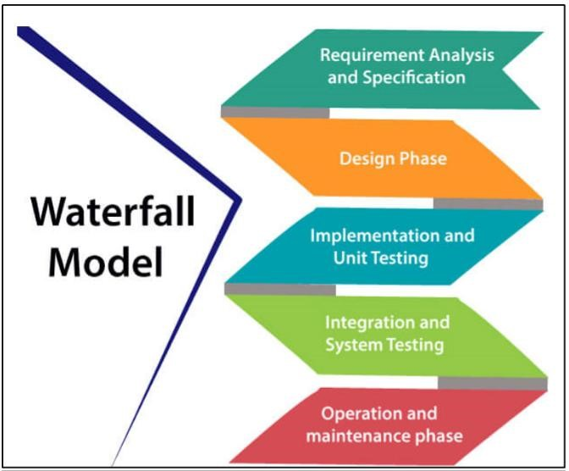

The six stages above are as follows:

**I. Requirement Analysis and Definition:**

What- The systems services, constraints and goals are established by consultation with system users. They are then defined in detail and serve as a system specification.

**II. System and Software Design:**

How – The system design process partitions the requirements to either hardware of software systems. It establishes and overall system architecture. Software design involves fundamental system abstractions and their relationships

**III.Implementation and Unit Testing: -**

How – During this stage the software design is realized as a set of programs or program units. Unit testing involves verifying that each unit meets its specifications.

**IV. Integration and system testing:**

The individual program unit or programs are integrated and tested as a complete system to ensure that the software requirements have been met. After testing, the software system is delivered to the customer.

**V.Deployment:-**

In the Deployment phase, the focus is on ensuring a smooth transition of the software from development to production, and making it available to end-users. This phase involves final testing, packaging, distribution, installation, configuration, user training, and documentation. Once the software is successfully deployed, it is handed over to the maintenance team for ongoing support and maintenance.

**VI. Operation and Maintenance:**

Normally this is the longest phase of the software life cycle. The system is installed and put into practical use. Maintenance involves correcting errors which were not discovered in earlier stages of the life-cycle, improving the implementation of system units and enhancing the system’s services as new requirements are discovered

**2.Spiral Modal:**

The Spiral Model is a [**Software Development Life Cycle (SDLC)**](https://www.geeksforgeeks.org/software-development-life-cycle-sdlc/) model that provides a systematic and iterative approach to software development. In its diagrammatic representation, looks like a spiral with many loops. The exact number of loops of the spiral is unknown and can vary from project to project. Each loop of the spiral is called a **Phase of the**software development.

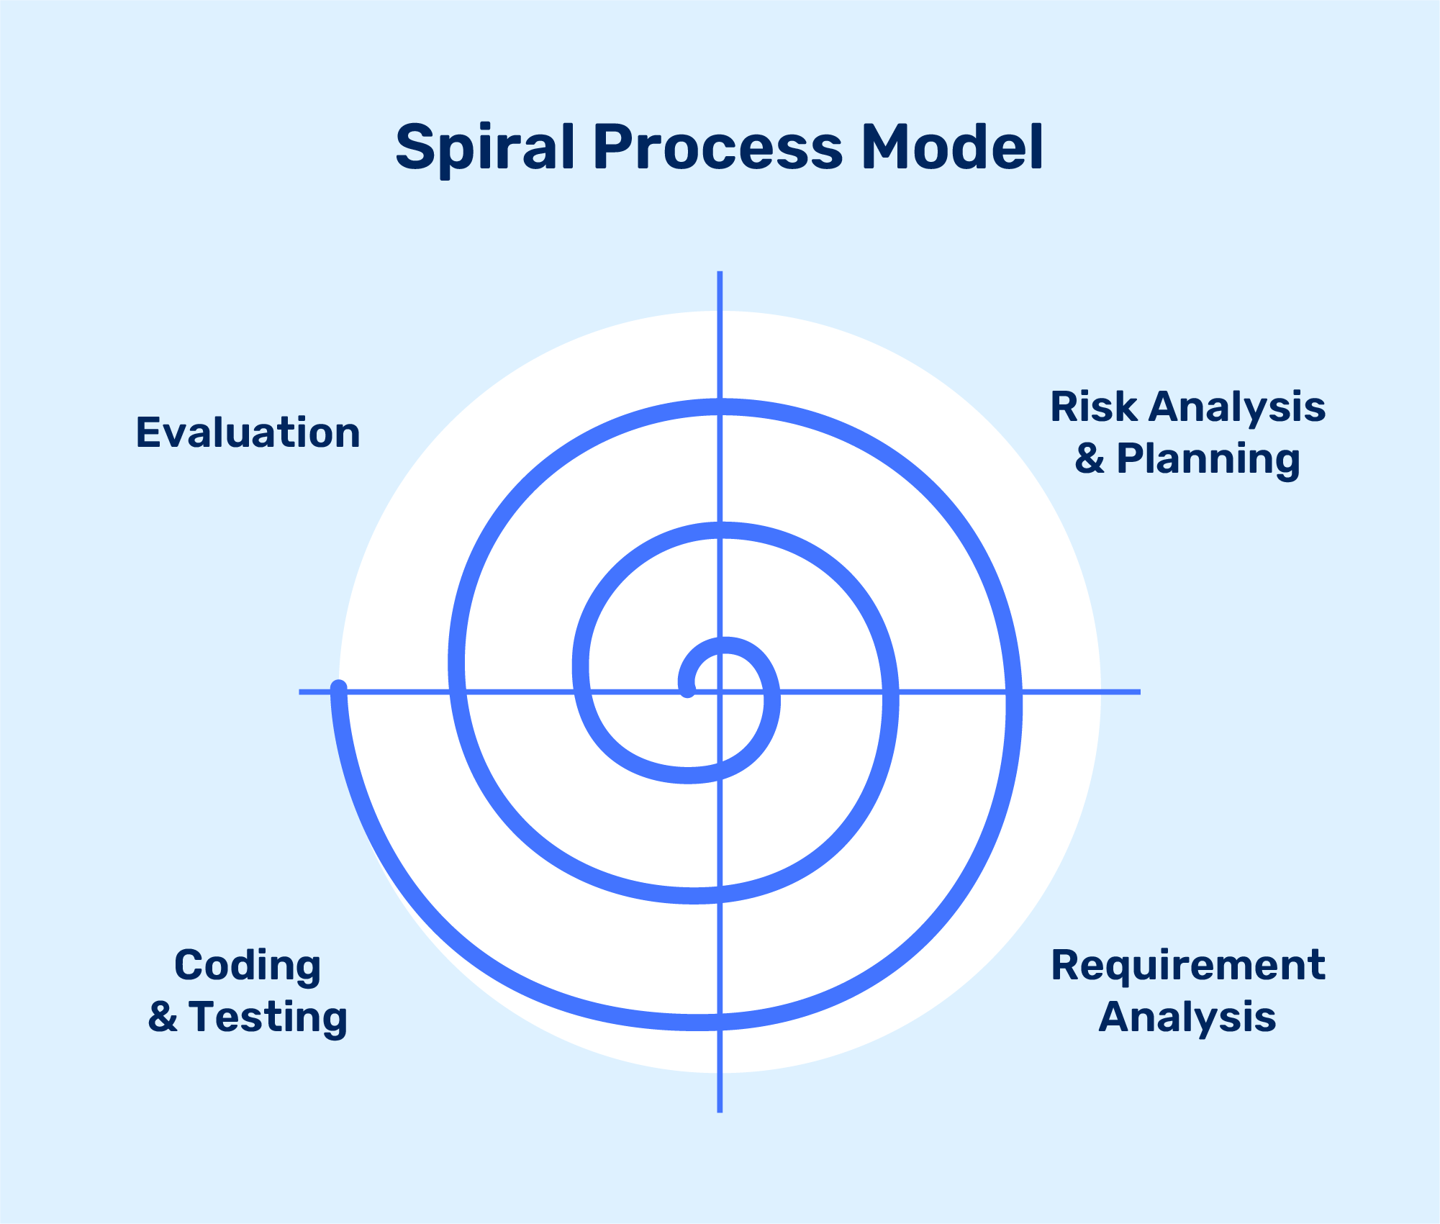

**I. Objectives determination and identify alternative solutions:**

In this first quadrant, the main goal is to gather as much information as possible from the customers. This includes understanding their needs, expectations, and any constraints they may have. Once the objectives are clearly defined, the team starts brainstorming different solutions that could meet these objectives. These solutions are then evaluated based on their feasibility, cost, time, and alignment with the customer’s requirements. The best solutions are shortlisted for further analysis in the next quadrant.

**II. Identify and resolve Risks:**

The second quadrant is all about risk management. The team evaluates the shortlisted solutions from the first quadrant and identifies potential risks associated with each one. These risks could be technical, financial, operational, or even related to the market or customer preferences. Once the risks are identified, the team develops strategies to mitigate them. This could involve modifying the solution, developing contingency plans, or even discarding the solution if the risks are too high. The end result of this quadrant is a prototype of the chosen solution, which is then tested and refined in the next quadrant.

Develop the next version of the Product:

**III. The third quadrant is where the actual development happens.**

Based on the prototype from the second quadrant, the team starts building the features of the product. This involves coding, testing, and debugging. The team also verifies that the product meets the objectives defined in the first quadrant and that the risks identified in the second quadrant have been effectively mitigated. By the end of this quadrant, a new version of the product is ready for review.

**IV. Review and plan for the next Phase:**

The fourth and final quadrant involves reviewing the product with the customers. They evaluate the product to ensure it meets their needs and provides value. The team collects feedback and uses it to improve the product in the next phase. This quadrant also involves planning for the next phase of the Spiral Model, which could involve scaling the product, adding new features, or even starting a new project.

**Choosen Methodology:-**

I will choose vu process Model for my project which is the combination of waterfall and spiral model.

**3.VU Process Model:**

A structured methodology for process management and improvement, comprising four sequential stages.

**I. Vision (Definition and Goal-Setting)**

Define the desired future state of the process (Vision Statement)

Establish clear goals and objectives (SMART criteria)

Identify key performance indicators (KPIs) to measure success

Define the scope and boundaries of the process

Identify stakeholders and their requirements

**II. Understanding (Current State Assessment)**

Analyze the current state of the process (As-Is process mapping)

Identify strengths, weaknesses, opportunities, and threats (SWOT analysis)

Gather data and feedback from stakeholders (surveys, interviews, etc.)

Identify pain points and areas for improvement

Document the current process (process mapping, procedures, etc.)

**III. Upgrading (Process Improvement and Implementation)**

Design and implement process improvements (To-Be process mapping)

Develop new procedures and standards

Train and support stakeholders

Develop a change management plan

Implement the new process (transition from As-Is to To-Be)

**IV. Validation (Monitoring and Evaluation)**

Monitor and evaluate the improved process

Measure KPIs and adjust as needed

Continuously review and refine the process to ensure sustainability

Celebrate successes and recognize improvements

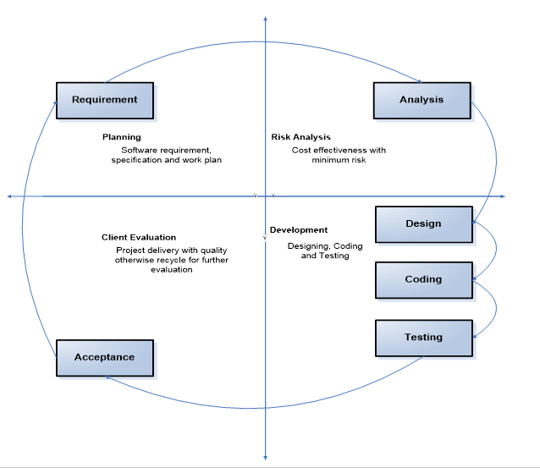

Reasons For Choosing:-

**I.Structured Approach:**

The VU Process Model emphasizes a structured approach to software development. It ensures that you follow a systematic sequence of steps, from requirements gathering to testing and deployment.

**II. Early Specifications and Design:**

Before writing a single line of code, the VU Process Model focuses on creating detailed specifications and design documentation. This minimizes wastage of effort and time and reduces the risk of schedule slippage or unmet customer expectations1.

**III. Risk Management:**

Like the Spiral Model, the VU Process Model incorporates risk management. It allows you to identify and address potential risks early in the project. By iteratively assessing risks, you can make informed decisions and adjust your approach as needed.

**IV. Adaptability:**

The VU Process Model allows for flexibility. You can adapt it to suit your project’s specific needs. For instance, if certain requirements change during development, you can adjust the design and specifications accordingly.

**V. Clear Documentation:**

The model encourages comprehensive documentation at each stage. This documentation serves as a valuable reference for team members, stakeholders, and future maintenance.

**VI. Gantt Chart Planning:**

The VU Process Model recommends creating a Gantt chart to visualize project activities and milestones. This helps manage project timelines effectively

# *WorkPlan:-*

